Boat Self-Cleaning Checklist
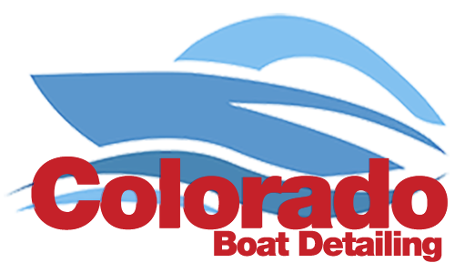
🔲 Remove All Trash From Boat
🔲 Remove All Gear From Boat
🔲 Remove All Perishable Food From Boat
🔲 Load-Out Items Are All Stowed/Stored
🔲 Spray Outside of Boat & Hull (regular hose with fresh water)
🔲 Wipe-Down Inside
-all topside Interior surfaces
🔲 If you have one; pump out the holding tank
🔲 Vacuum Interior

